Assignment WBS Monitor

Date : 20-Mar-2017

By : Peter Nocker ([p.nocker@roc-teraa.nl](mailto:p.nocker@roc-teraa.nl)), Joris van den Dries ([j.v.d.dries@roc-teraa.nl](mailto:j.v.d.dries@roc-teraa.nl))  
 Benjamin Porobic ([b.porobic@roc-teraa.nl](mailto:b.porobic@roc-teraa.nl))

Hours : 16 hours (4 weeks, 4 hours a week)

Assessment : individual

Read the assignment carefully and ask questions if anything is not clear.

# Introduction

When you develop a product it’s important to know how much time you will and have spent on a project, because you don’t want to spend more time than you get paid for. The easiest way to make a project schedule is to use Microsoft Excel. But the big disadvantage of using Excel is that it is not a real time tracking software, when you finish a task you have to add the time manually. In the following weeks you will “translate” this spreadsheet in to a web application named: WBS Monitor.

WBS Monitor is a time tracking web application, with the possibility to track tasks from multiple projects. To develop WBS Monitor you will use the following programming languages and techniques: HTML, CSS, PHP, jQuery, AJAX, Twitter Bootstrap.

Smartphones and tablets are popular devices to browse the internet. That is why it is important to make your WBS Monitor responsive. This means that the layout of your website adapts to the viewing device of the visitor. To make your website mobile friendly you will be using Twitter Bootstrap.

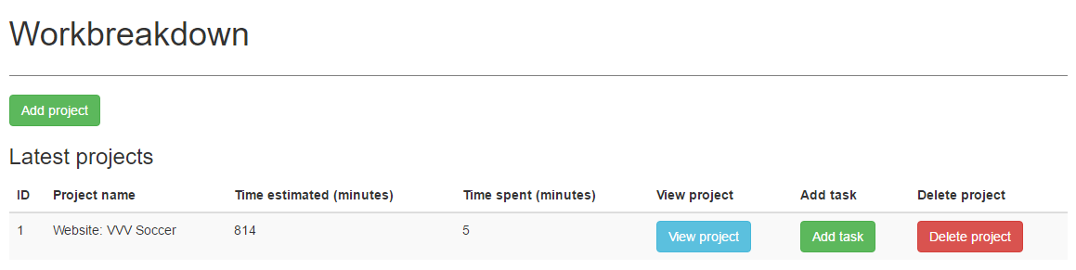

Figure 1 Projects overview page

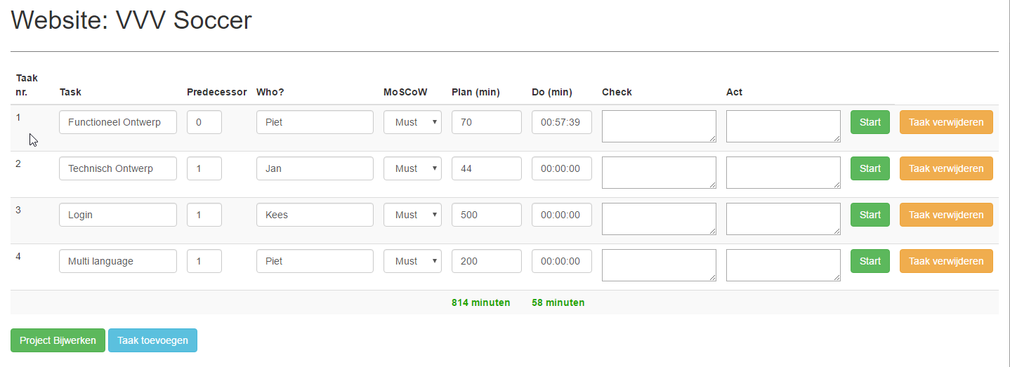

Figure 2 Project detail page

Prior knowledge

To successfully complete this assignment it is necessary to have a good understanding of HTML, CSS, jQuery, AJAX and PHP.

# Must

* Possibility to add unlimited number of projects
* Possibility to add unlimited number of tasks per project
* Every task consists of the following input fields: task name, predecessor, name of the developer, MoSCoW, plan, do, check & act (see figure 2)
* Track time per task
* Show total time you expect to work on all the tasks together (plan)
* Show total time spent on all the task (do)
* Entity Relations Diagram (ERD)
* Responsive / mobile-friendly
* Clean code: no inline CSS, jQuery, separate PHP from HTML (Use includes)
* Organize files and folders

# Should

* Possibility to delete projects and tasks
  + When you delete an entire project all the tasks of that project should be removed from the database
  + When you delete a task the total time updates
* Form validation (check for correct input and empty fields)
* User feedback (feedback messages):
  + Show a message when users want to delete a task or project
  + Notification when users add a task and project
* Indicate with a colour that the time you actually spent on a specific task (do) is more than the time you have planned (plan) for that task.
* Indicate with a colour or icon that the total time you spent (do) on all the tasks together is more than the time you planned (plan).
* Test your website in different browsers and devices. Show a test plan that you have tested your WBS Monitor in different browsers.
* Normalize your database, your database structure should be efficiently organized

# Could

* Make a login
* Make a filter on the project detail page
* Use a PHP-framework (if familiar, during this project you won’t be taught how to use a PHP-framework)

# Won’t

* Use a template

Tips, Resources

* Use classroom examples and PowerPoint sheets from N@tschool.
* Make backups: external hard drive or cloud storage
* Upload your finished assignment in N@tschool. Use Winrar or 7-zip to pack your files
  + Only .7zip or .rar file extension allowed
* Test your WBS Monitor in different browsers and devices
* http://jquerytimer.com/
* https://api.jquery.com/
* [www.codecademy.com](http://www.codecademy.com)
* www.freecodecamp.com
* Work together if necessary, but **do not copy**. **In case of fraud, an additional assignment will follow in the last weeks of the school year**